Assignment-7.6:

Write a map reduce program save the output of the word count program in XML format. You need to write a custom writable to save the output in XML format.

In this assignment, I have used a sample text file .

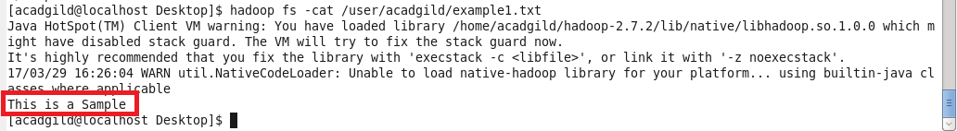

Driver Class:

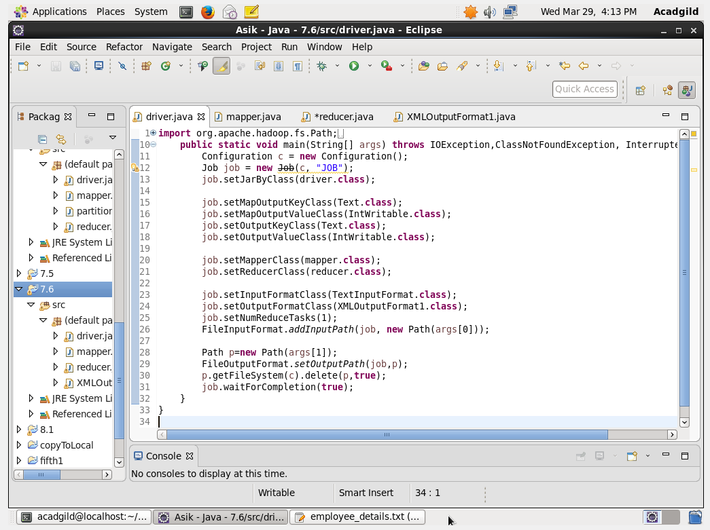

Mapper Class:

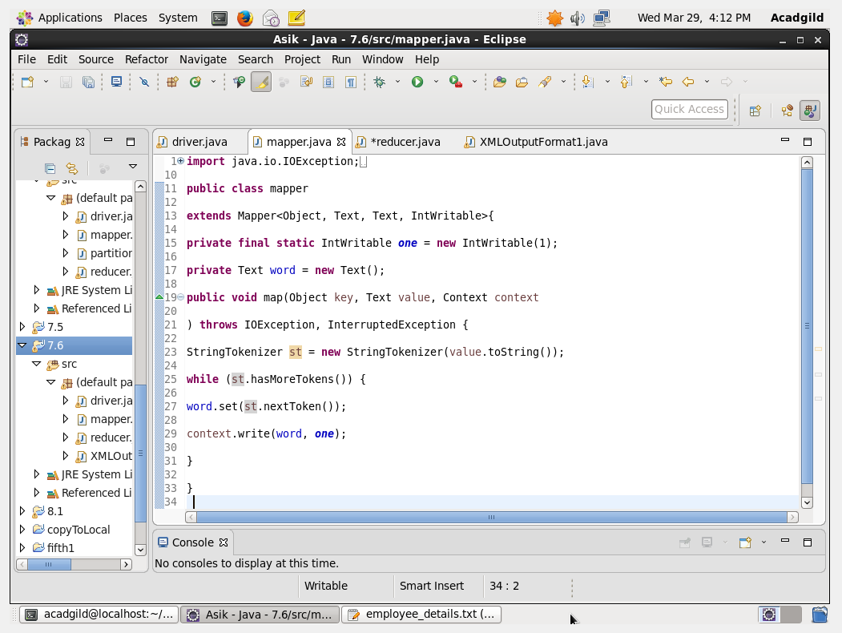

Reducer Class:

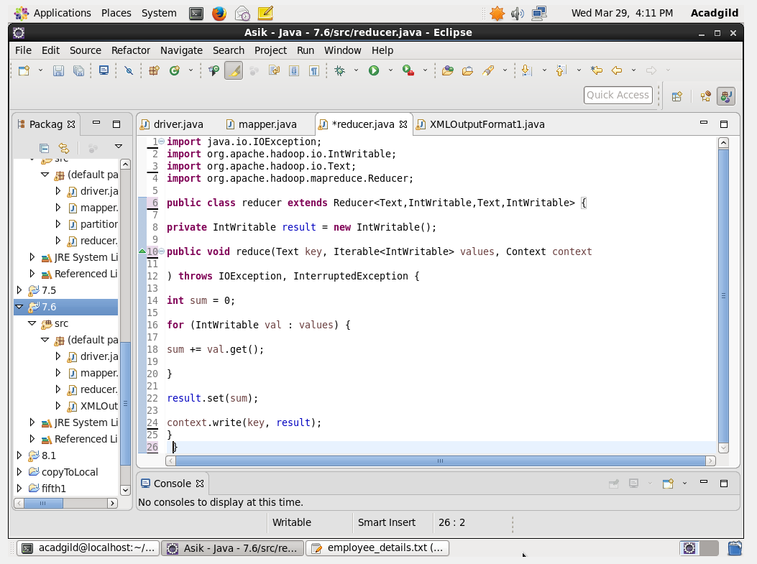

XMLOutputFormat Class:

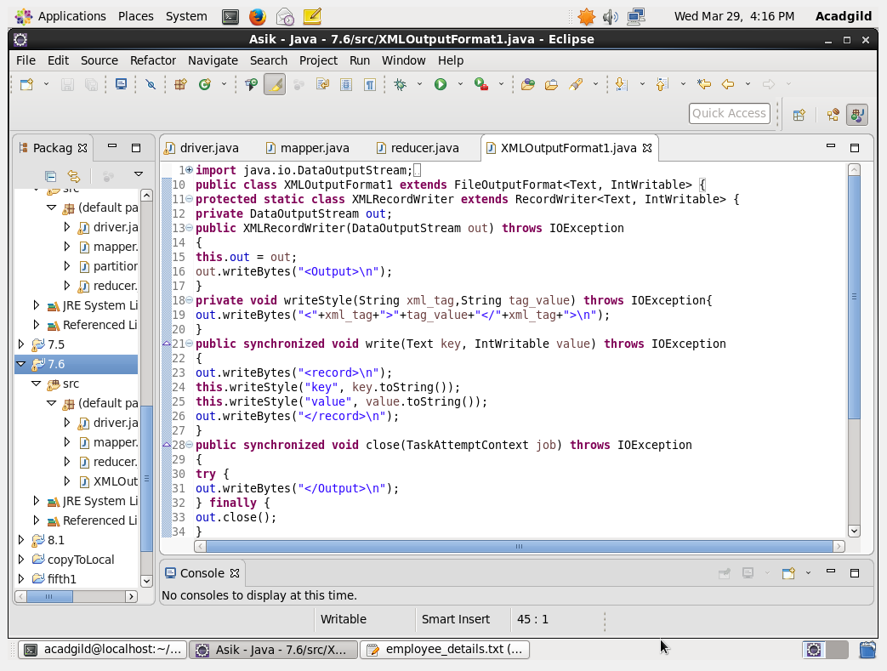

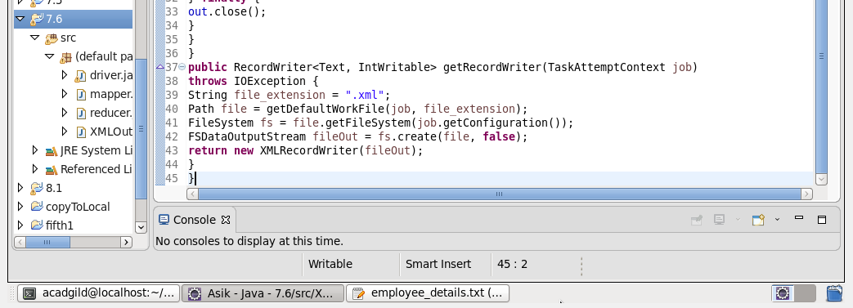

Executing the jar file:

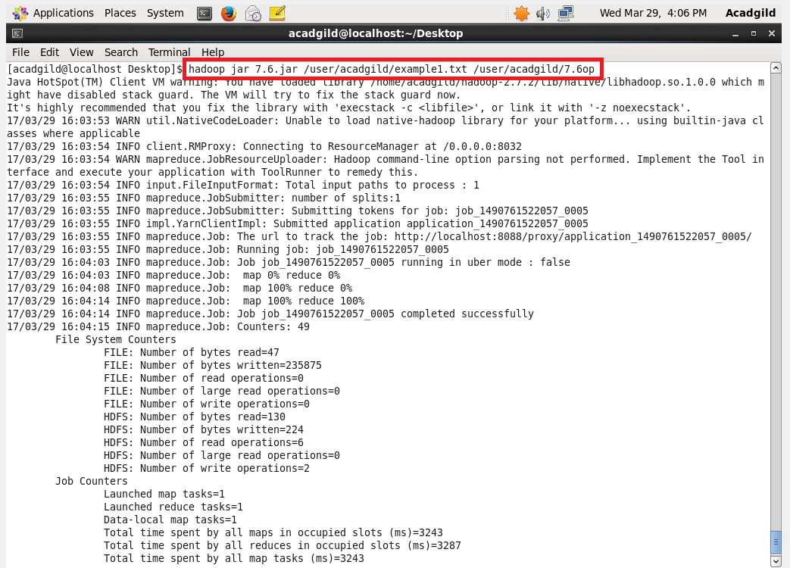

Output:

